LAB CAMERA
Họ tên: Trần Anh Khoa
MSSV: 2211644

Bài 1:
Hình 1:
gluLookAt(0, 0, 10, 0.0, 0.0, 0.0, 0.0, 1.0, 0.0);
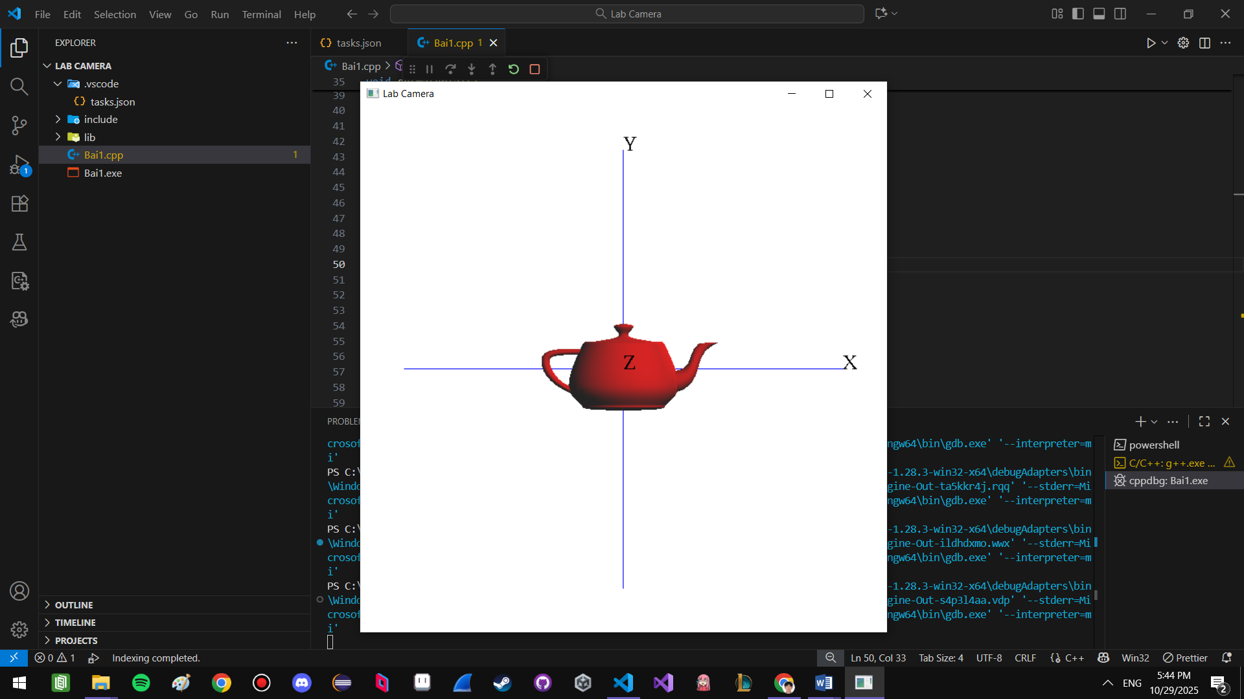

Hình 2:
gluLookAt(0, 0, -10, 0.0, 0.0, 0.0, 0.0, 1.0, 0.0);
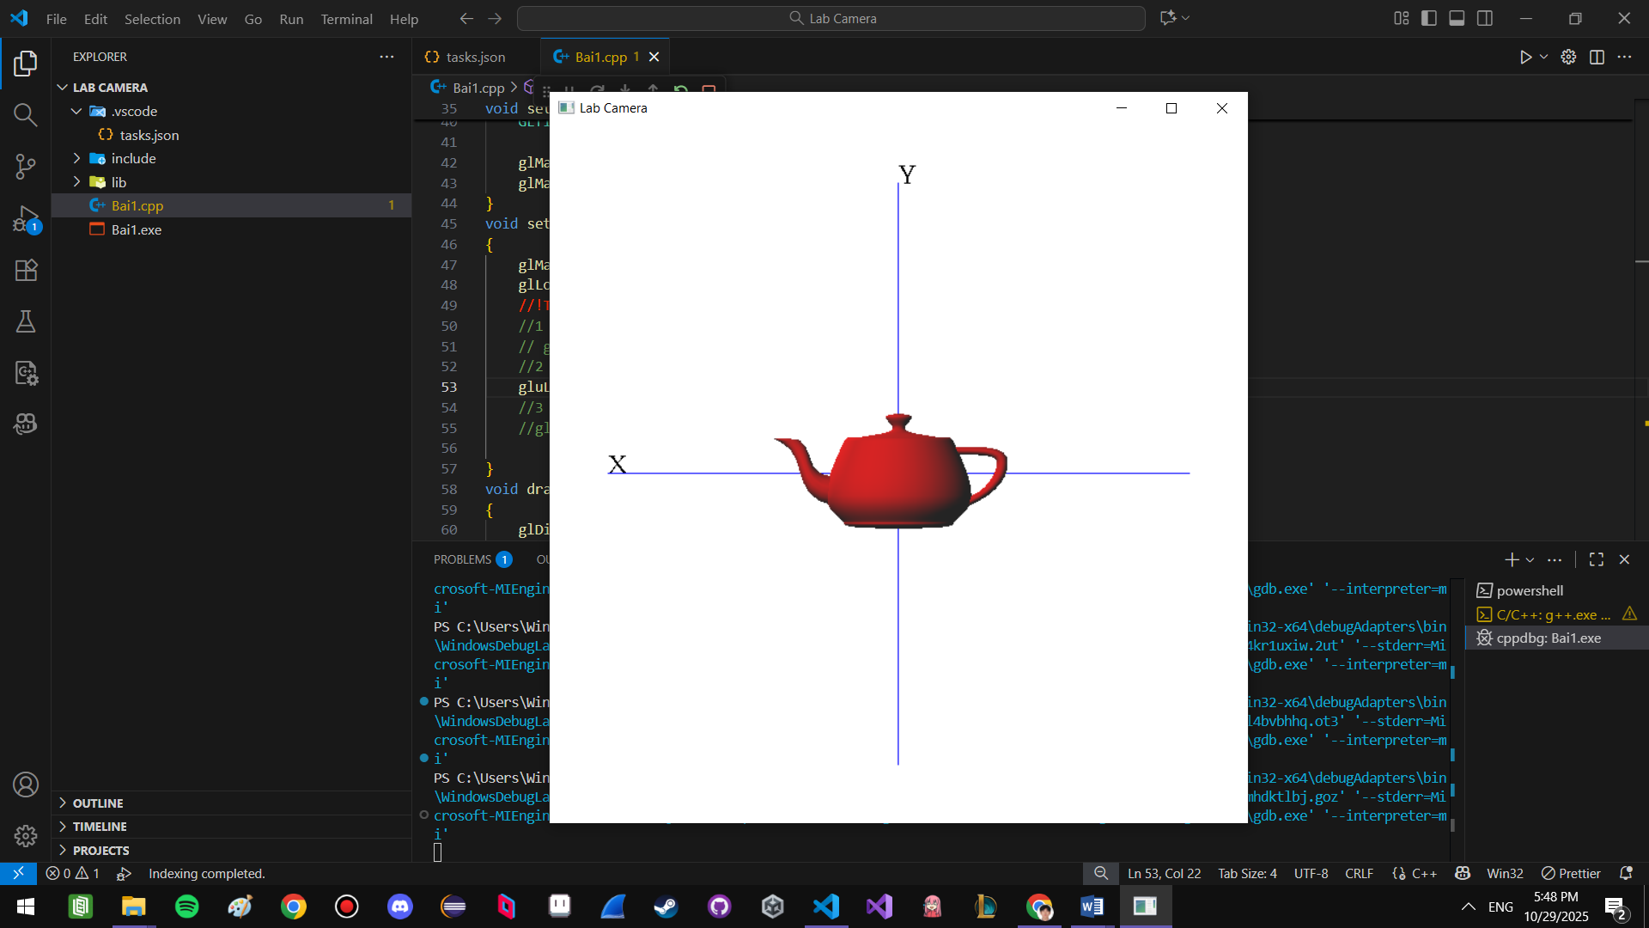

Hình 3:
gluLookAt(10, 0, 0, 0.0, 0.0, 0.0, 0.0, 1.0, 0.0);
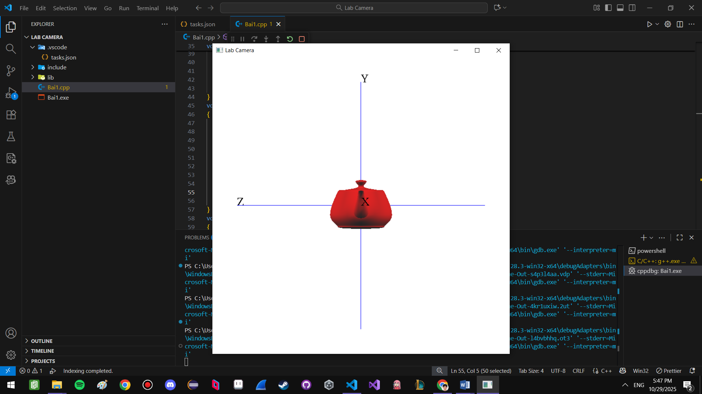

Hình 4:
gluLookAt(0, 10, 0, 0.0, 0.0, 0.0, 0.0, 0.0, 1.0);
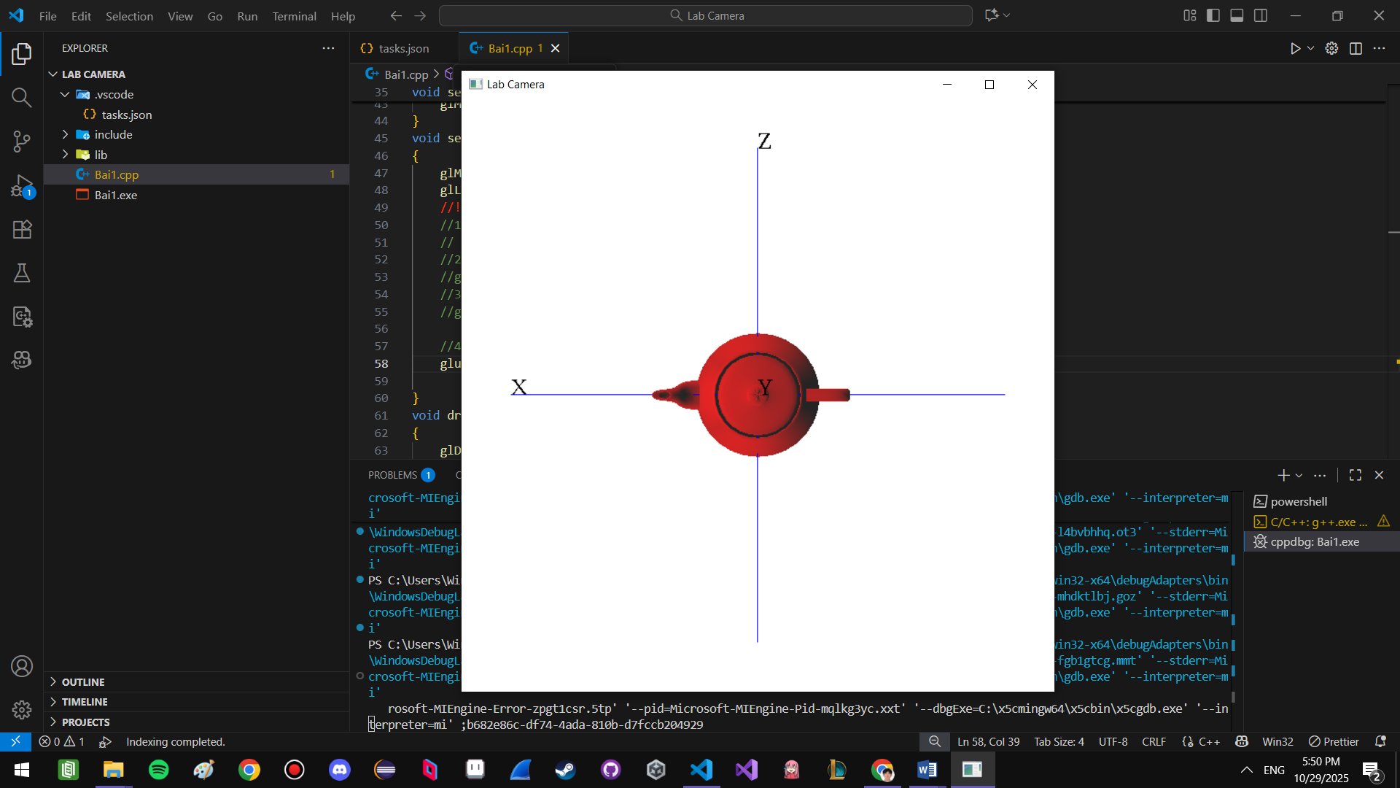

Hình 5:
gluLookAt(0, 10, 0, 0.0, 0.0, 0.0, 1.0, 0.0, 0.0);
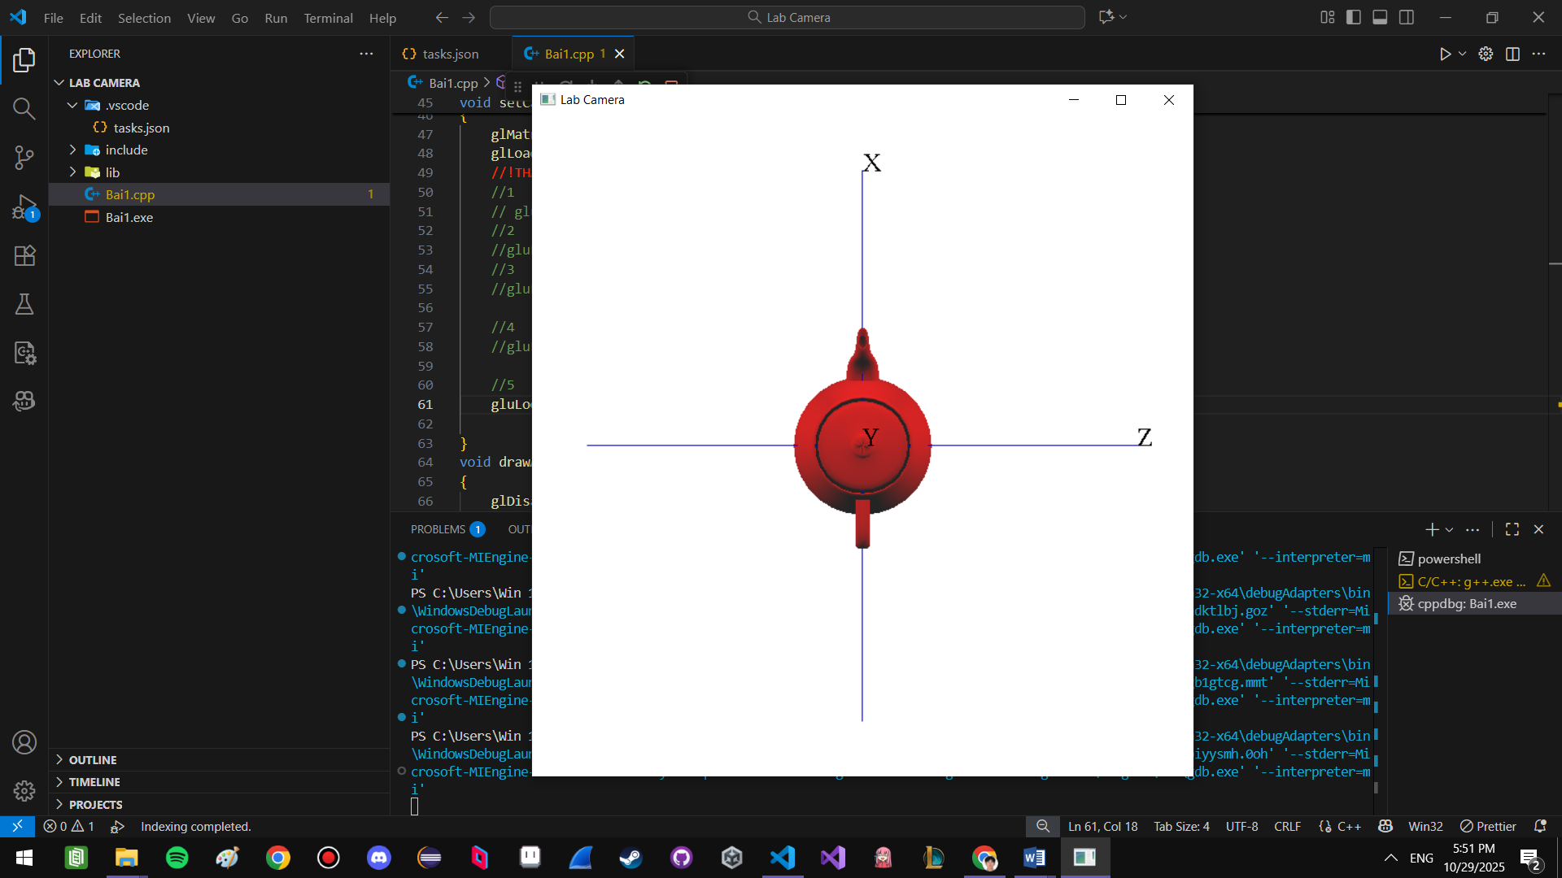

Hình 6:
gluLookAt(0, -10, 0, 0.0, 0.0, 0.0, -1.0, 0.0, 0.0);
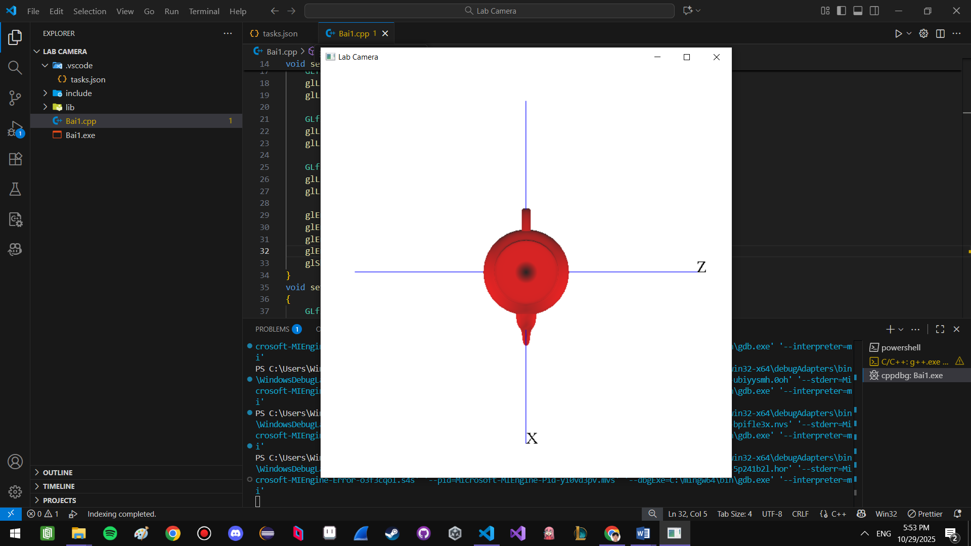

Hình 7:
gluLookAt(10, 5, 10, 0.0, 0.0, 0.0, 0.0, 1.0, 0.0);
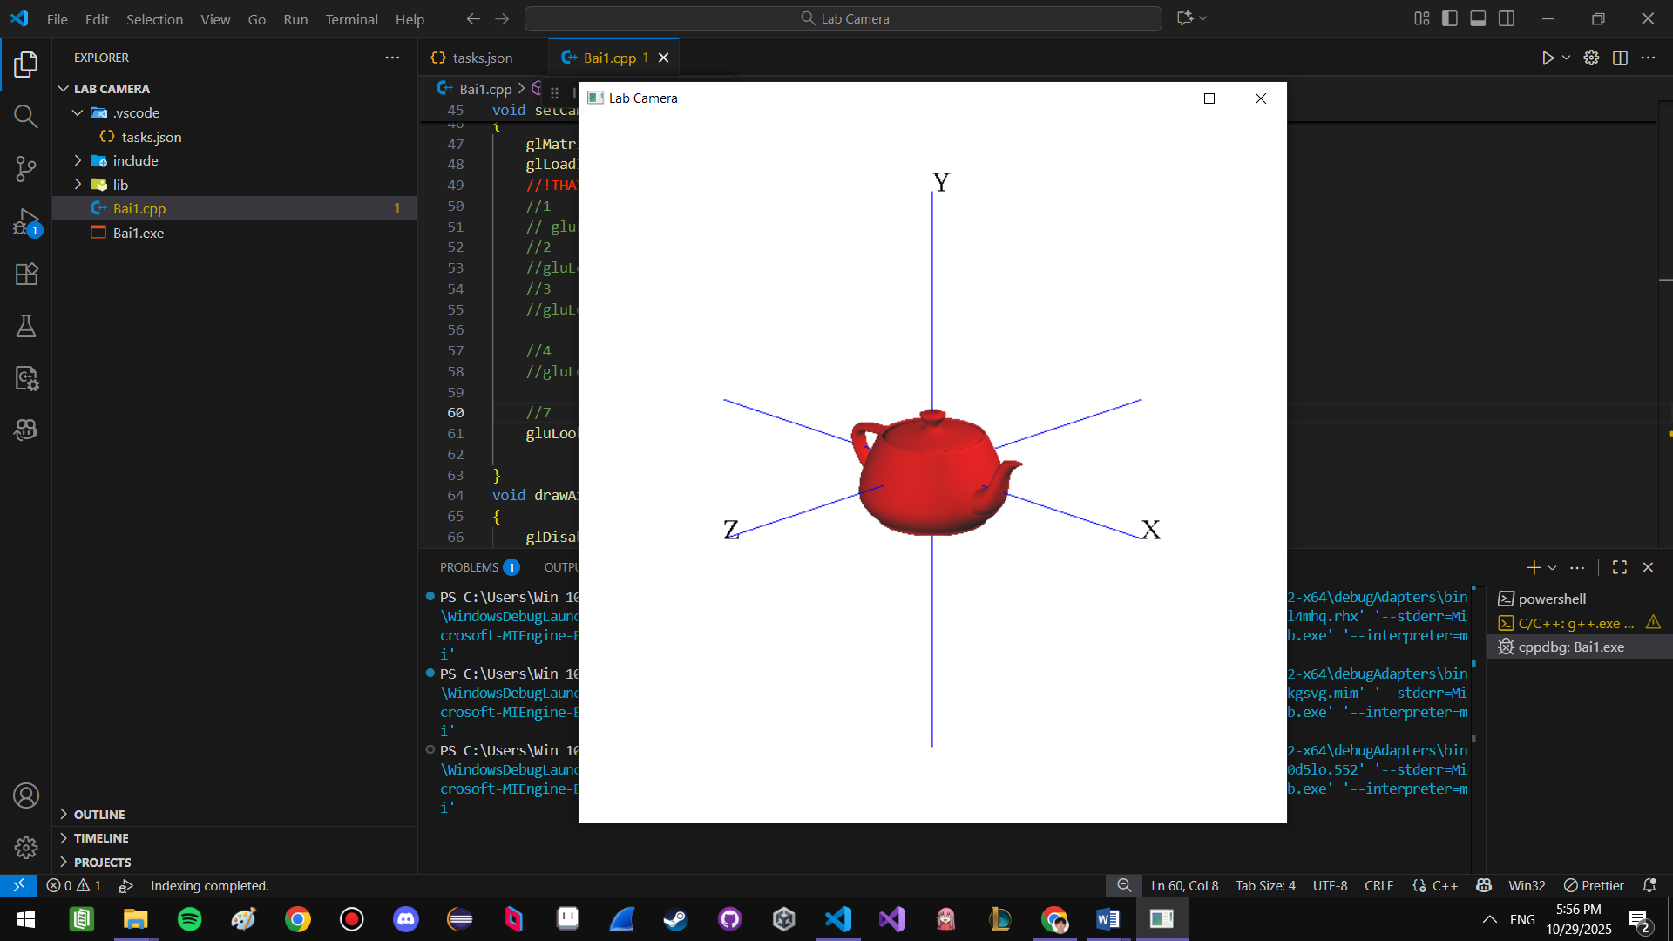

Hình 8:
gluLookAt(-10, 5, -10, 0.0, 0.0, 0.0, 0.0, 1.0, 0.0);
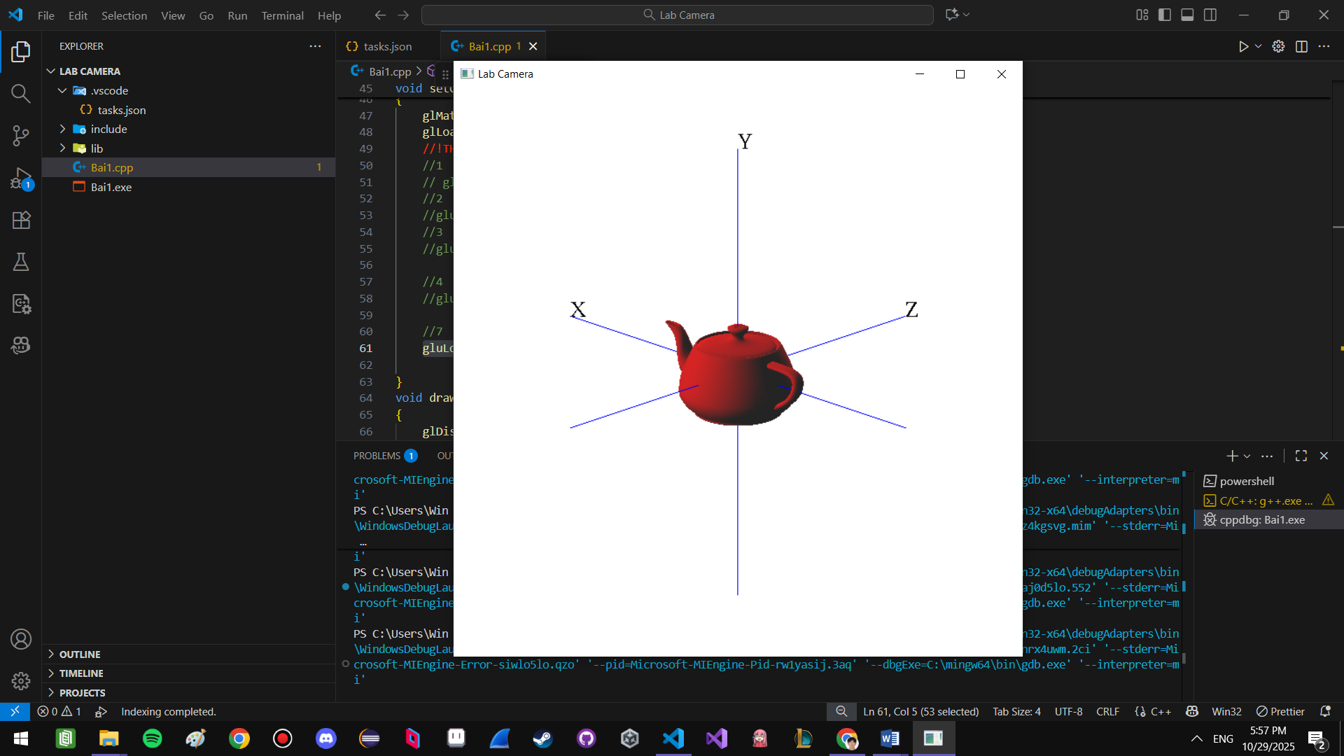

Hình 9:
gluLookAt(10, -5, 10, 0.0, 0.0, 0.0, 0.0, 1.0, 0.0);
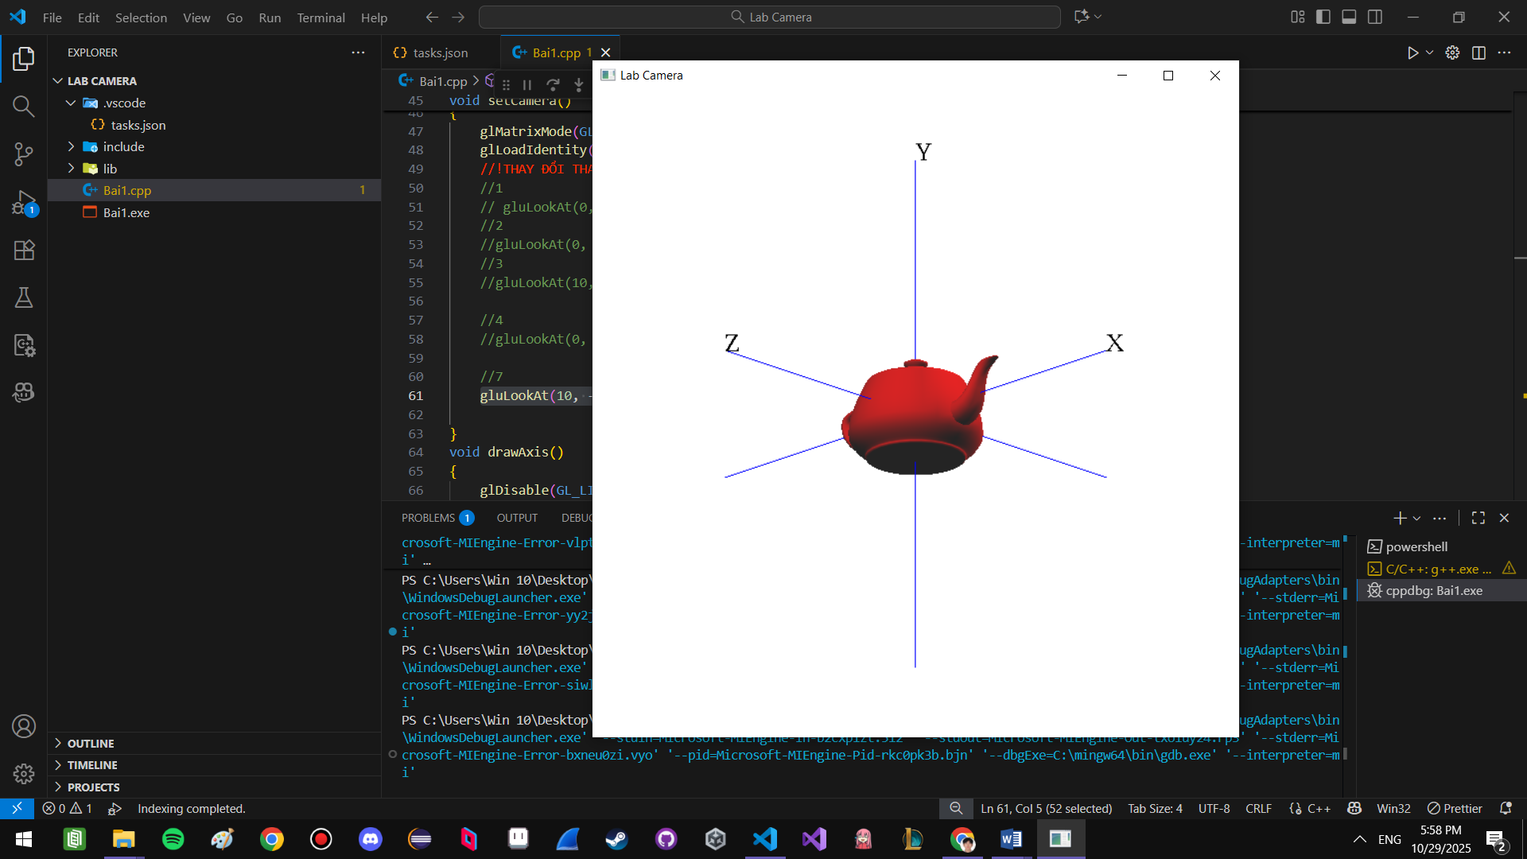

Hình 10:
gluLookAt(10, -5, 10, 0.0, -0.5, 0.0, 0.0, 1.0, 0.0);
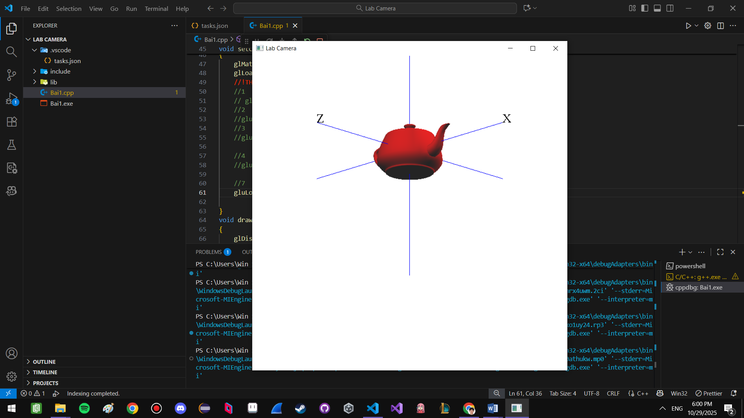

Bài 3:
void mySpecialKeyboard(int theKey, int mouseX, int mouseY)
{
//Code here
switch(theKey)
{
case GLUT_KEY_UP:
camera_height += 0.1;
changeCameraPos();
break;
case GLUT_KEY_DOWN:
camera_height -= 0.1;
changeCameraPos();
break;
case GLUT_KEY_LEFT:
camera_angle += 1;
changeCameraPos();
break;
case GLUT_KEY_RIGHT:
camera_angle -= 1;
changeCameraPos();
break;
}
}
void myKeyboard(unsigned char key, int x, int y)
{
switch(key)
{
//Code here
case 'V':
case 'v':
b4View = !b4View;
break;
case '+':
camera_dis += 0.1;
changeCameraPos();
break;
case '-':
camera_dis -= 0.1;
changeCameraPos();
break;
}
glutPostRedisplay();
}

void DisplayOneView(int nType, int left, int right, int top, int bottom)
{
mySetupCameraVolume(nType);
glViewport(left, top, right - left, bottom - top);
glMatrixMode(GL_MODELVIEW);
glLoadIdentity();
//Code here
if(nType == 1)
gluLookAt(0, camera_dis, 0.0, 0.0, 0.0, 0.0, 0.0, 0.0, 1.0);
else if(nType == 2)
gluLookAt(0, 0.0, camera_dis, 0.0, 0.0, 0.0, 0.0, 1.0, 0.0);
else if(nType == 3)
gluLookAt(camera_dis, 0.0, 0.0, 0.0, 0.0, 0.0, 0.0, 1.0, 0.0);
else
gluLookAt(camera_X, camera_Y, camera_Z, 0.0, 0.0, 0.0, 0.0, 1.0, 0.0);
//
glColor3f(0, 0, 1);
glutSolidTeapot(2);
}

void myDisplay()
{
glClear(GL_COLOR_BUFFER_BIT | GL_DEPTH_BUFFER_BIT);
if(b4View == false)
{
DisplayOneView(4, 0, screenWidth, 0, screenHeight);
}
else
{
//Code here
DisplayOneView(1, 0, screenWidth/2, 0, screenHeight/2);
DisplayOneView(2, 0, screenWidth/2, screenHeight/2, screenHeight);
DisplayOneView(3, screenWidth/2, screenWidth, screenHeight/2, screenHeight);
DisplayOneView(4, screenWidth/2, screenWidth, 0, screenHeight/2);
//
}
glFlush();
glutSwapBuffers();
}
